Activity I Exploring Energy Resource Concepts

Radiation is important to the community for many reasons. Solar radiation causes things in the community to be heated. Solar radiation heated the solar cooker. It also heats someone standing in the sunshine on a cold winter day, or a parked car in the Sun in the summer with all its windows closed. If a building is designed appropriately, the heat from the Sun can substitute for heat from other energy resources for space heating and hot water. Using insulation or light-colored reflective materials reduces solar heating in warmer months when heat is not desired.

Energy, Work, and Power

In the investigation, you dealt with four forms of energy: energy of motion, called kinetic energy; energy of position, called potential energy; energy stored in the chemical bonds of a substance, called chemical energy, and heat. Kinetic energy and potential energy together are called mechanical energy. You know that objects in motion have energy, because of what they can do to you when they hit you. The energy of motion is called kinetic energy. The more mass the body has, and the faster it is moving, the more kinetic energy it has. When you threw (or imagined throwing) the lump of modeling clay up in the air, you gave it kinetic energy. The kinetic energy was gradually converted to potential energy. When the lump reached its highest point, its kinetic energy was at a minimum. On the way down, the lump regained its kinetic energy. When it hit the table, all of its kinetic energy was changed to heat. The change in temperature was so small that you would need a very sensitive thermometer- to measure it. That's an example of how kinetic energy is changed to heat energy by friction. When you rub your hands together to keep them warm, you are converting kinetic energy to heat by friction. Of course, you are always resupplying your hands with kinetic energy by the action of
into your arm muscles.
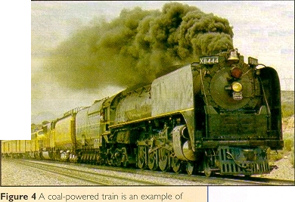

Geo Words
potential energy: mechanical energy associated with position in a gravity field; matter farther away from the center has a higher potential energy

chemical energy: energy stored in a chemical compound which can be released during chemical reactions, including combustion.

mechanical energy: the sum of the kinetic energy and the potential energy of a body of matter.

friction: the force exerted by body of matter when it sides past another body of matter.

EarthComm

